**The Evolution of Accessibility Through Technology, Testing, And Compliance**

ATARC- YRD (6/29/20)

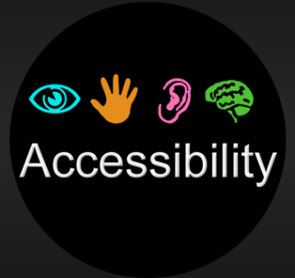It’s been nearly 20 years since the Americans Disability Act (ADA) was amended to include web accessibility. Web, and now digital accessibility, establishes standards and guidelines that require a keen adherence to “accessible design” (*a design process in which the needs of people with disabilities are specifically considered*).

Section 508 (Rehabilitation Act of 1973), amended in 1998, to develop accessibility standards for software, hardware, websites, videos, and other IT products and services. Depending on the angle from which you view these requirements, they can extend to all of society, apply solely to industry professionals, and/or apply uniquely to local, state, and federal government.

Accessible design (*acccessiblity*) is where product and content owners, developers and designers, and other key stakeholders of IT solutions (*websites, mobile applications, software programs, etc*.) have a legal, business, and moral obligation to commit to best practice solutions based on legal and technical case studies, use cases, and user stories, as prescribed under laws, standards, and guidelines such as those that fall under the World Wide Web Consortium (W3C)'s Web Accessibility Initiative (WAI). Some accessibility guidelines are generic while others are specifically based on system components *(*See* [*https://en.wikipedia.org/wiki/Web_Accessibility_Initiative*](https://en.wikipedia.org/wiki/Web_Accessibility_Initiative) *for a list of interest groups and working groups*):

* Authoring Tool Accessibility Guidelines (ATAG)
* Web Content Accessibility Guidelines (WCAG)
* User Agent Accessibility Guidelines (UAAG)

**GAO Reports/Findings**

As an oversight and audit organization, this invaluable resource provides Congress, federal agencies, and the public timely information to improve government operations by avoiding fraud, waste, and abuse, recommending oversight practices and efficiencies in customer satisfaction and engagement, and saving billions in taxpayer dollars. When it comes to digital support services, GAO noted that many Americans use mobile devices to access websites for daily use (*research, shopping, banking, federal, state, and local government services, etc*.). The organization reviewed 5 years (2009 through 2013) of online visitor data from multiple agencies. This included types of devices (*smartphone, tablet, or desktop computer*) consumers used to access the agencies’ main website. GAO interviewed the agency officials to discuss the potential challenges the public might face when accessing government services using their mobile devices. The GAO found that best practice implementation has greatly improved access to agency websites via mobile devices.

**Testing, Monitoring, and Compliance Tools (Example - Deque Systems, Inc.)**

Organizations are less likely to meet their project’s cost, scope, and timelines if they discover problems later (*at the end of the project*) rather than sooner (*at the beginning of the project*). The next two diagrams are taken from a demo presentation highlighting the benefits of continuous accessibility testing throughout the software development lifecycle (SDLC) process. Although this is a Canadian company, these are universal solutions due to international standards and guidelines.

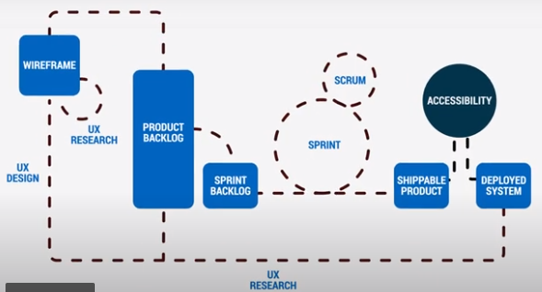

**Agile Project Lifecycle with Waterfall Testing at the End**



*\*Source:* [*https://www.deque.com/axe/devtools/*](https://www.deque.com/axe/devtools/)

***Solution –*** Test throughout the product-delivery process and not just at the end. The tool highlighted above demonstrates the accessibility testing tool as it runs in the local development environment as it integrates throughout the development toolchain. Continuous diagnostics & monitoring (CDM) is typically linked to IT system health and incident response in the cybersecurity and IT security space, but testing lifecycle management and ‘test centers of excellence (TCoEs) are also big components of quality assurance (QA).

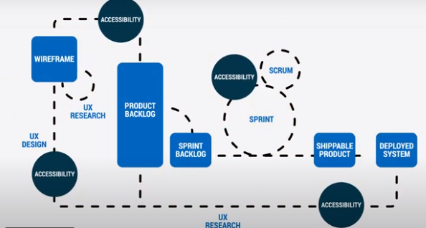

**Continuous Testing and Monitoring Throughout the Lifecycle**

The combination of accessibility checks in regular developer (code) testing and manual testing by specialists during quality assurance (QA testing) help bring accessibility goals to the intended maturity levels, saving developers and product owners precious time from documenting bugs and fixes later. Ultimately resulting in web and digital services that are correctly designed, developed and edited for equitable user access to information and functionality.

**Conclusion / Recommendation**

Accessibility and usability (*accessible, useable, and universal design*) are fundamental requirements of compliance law. These practices should keenly incorporate all of the necessary requirements to build customer satisfaction and customer engagement, as well as, to avoid compliance issues, lawsuits and fines throughout the product life cycle. This blog highly recommends Investments in getting to know your user-base on multiple levels, investing in technology and testing tools to meet accessibility goals, and hiring accessibility, usability, and 508 compliance specialists to guide proven results before and after going Live.