ATARC Customer Experience Working Group

April 7, 2021

The purpose of this document is to outline the intent, scope, and general operating model of the Customer Experience working group.

Context and Scope
- Customer Experience (CX) is the sum of all interactions between a customer and an organization throughout the business relationship.
- A 2020 Pew Research survey found that just 20% of American’s trust the federal government.
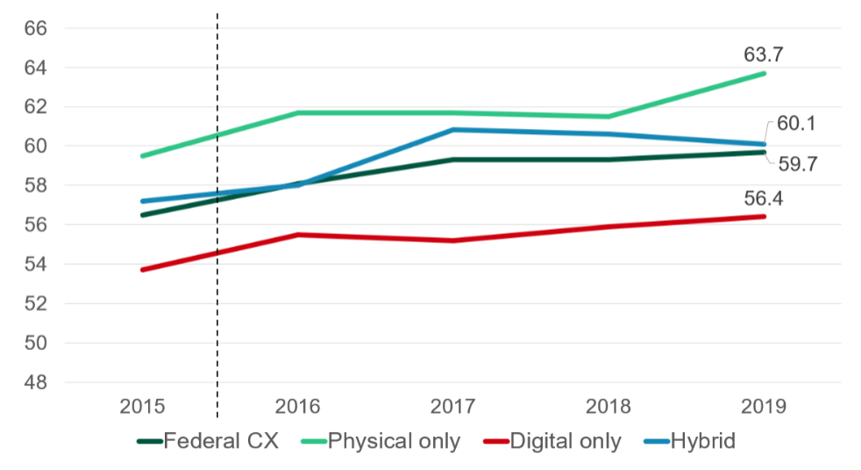
- When planning out Customer Experience initiatives, it is important to recognize Forrester’s Customer Experience research which notes that the federal digital CX drags down the whole experience:

Source: Forrester

While progress is being made to modernize websites through the 21st Century IDEA Act, it important to note that

Section 6
reads, “The Chief Information Officer of each executive agency, or a designee, shall— (1) coordinate and ensure alignment of the internal and external customer experience programs and strategy of the executive agency;”. Part 6 signifies that the CIO might consider taking a greater role in their Agency’s CX improvement initiatives.
- Define customers- A 11 Section 280.2 reads, “’customer’” are individuals, businesses, and organizations (such as grantees, state and municipal agencies) that interact with a Federal Government agency or program, either directly or via a Federal contractor or even a Federally-funded program. Federal government customers could also include public servants and employees themselves in their interactions with Federal processes.”
- ATARC is bringing both a government and industry perspective with CX initiatives.
- CX varies across federal agencies.
- Vaccine rollout is an example of varying CX experience across federal, state, and local agencies.

The purpose of this Working Group is not to propose solutions prior to understanding customer needs, but to help CIOs begin to understand where they might look to find areas of CX improvement.

CX in Industry
CX is the powerful tool to disrupt the market. A recent Walker study found that customers want to do business with companies that know their individual needs and tailor the experience to meet individual’s needs. Customers value companies more if they provide real-time-responses and proactively anticipate future needs.
Add 3 E’s
CX Themes: (to remove: Output doc)
- Personalization
- Speed
- Simplicity of the experience
- Predict future needs

A recent McKinsey article stated, “A company’s competitive edge lies in seeing the world through the customer’s eyes.”

https://www.walkerinfo.com/docs/WALKER-Customers2020-ProgressReport.pdf

Objective
The objective of this working group is to improve CIO knowledge in the realm of Customer Experience Management and help them ideate and implement CX initiatives.
- Benchmarking against industry best practices.

Deliverables
The deliverable for this working group is the following:
- A brief checklist/recommendations to help CIOs understand which areas they might want to start to dig into improving the customer experience.

Cadence and Membership
The cadence of the meeting will be every other week from 3pm E.T. to 3:30pm E.T. on Thursdays. The Government Chair (Amber Chaudhry (Fiscal Service) will facilitate an environment to present new ideas and discussion topics. This environment will allow for ideas to be generated and added to the CIO checklist. A representative from ATARC will keep track of minutes/notes per meeting and make them available using the file sharing collaboration tool listed below.

Members
Name | Email | Agency/Business | Responsibilities
Nicole Mandes | nmandes@atarc.org | ATARC | Upload and disseminate documentation
Amber Chaudhry | amber.chaudhry@fiscal.treasury.gov | Bureau of Fiscal Service | Provide federal CX expertise and facilitator
Ramanuj Kushwaha | ramanuj@cisco.com | Cisco | Provide Industry experiewnce
 |  |  | Provide CX expertise
 |  |  | Provide CX expertise

Additional rosters of sub-groups are located in the sub-group folders in Huddle repository.

Rules of Engagement
The working group rules of engagement are described as below:

- Meet bi-weekly from 4/25/2021 to 2021

- Follow the group’s ground rules developed in the charter
- Decisions are made by the co-chairs

File Sharing and Collaboration Tools
Access
Access to the ATARC Huddle Instance is managed by Nicole Mandes (nmandes@atarc.org ).

Documentation Repository
Customer Experience Collaboration Folder:

Version Control
Version | Date | Author | Description
0.1 | 4/8/2021 | Amber Chaudhry | Initial Draft for Consideration and Comment
0.2 | 4/16/2021 | Ramanuj Kushwaha | Minor edits; added “CX in Industry” section

